**Project Design Phase-II**

**Data Flow Diagram & User Stories**

| Date | 20 May 2023 |
| --- | --- |
| Team ID | NM2023TMID13113 |
| Project Name | Reducing-the-Environmental-Footprint-of-Food-A-Comprehensive-Management-system |

**Data Flow Diagrams:**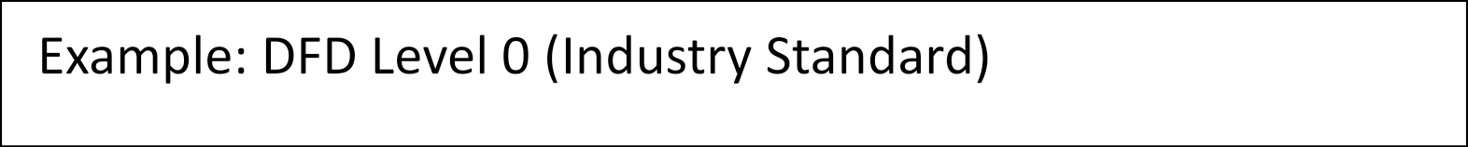

**Data Flow Diagram (DFD):**

**A Data Flow Diagram is a graphical representation of the flow of data within a system. It illustrates how data is input, processed, and output in a system. Here is a high-level Data Flow Diagram for the "Reducing the Environmental Footprint of Food: A Comprehensive Management System":**

**+--------------+**

**| User |**

**+--------------+**

**|**

**|1. Login**

**|**

**v**

**+--------------+**

**| System |**

**+--------------+**

**|**

**+----------------+----------------+**

**| |**

**| |**

**v v**

**+--------------+ +----------------+**

**| Data | | Data |**

**| Collection | | Analysis |**

**+--------------+ +----------------+**

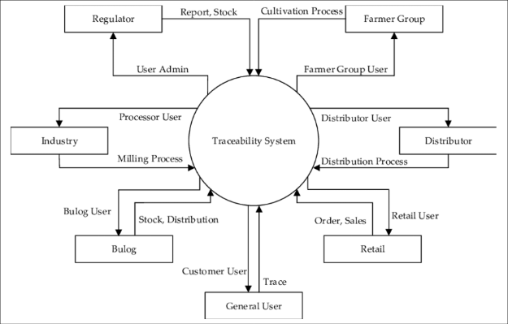

**User Stories**

Use the below template to list all the user stories for the product.

| **User Type** | **Functional Requirement (Epic)** | **User Story Number** | **User Story / Task** | **Acceptance criteria** | **Priority** | **Team Member** |
| --- | --- | --- | --- | --- | --- | --- |
| Customer (Mobile user) | Registration | USN-1 | As a user, I can register for the application by entering my email, password, and confirming my password. | I can access my account / dashboard | High | Devisri |
| Customer (Mobile user) | Registration | USN-2 | As a user, I will receive confirmation email once I have registered for the application | I can receive confirmation email & click confirm | High | Devisri |
| Customer (Mobile user) | Registration | USN-3 | As a user, I can register for the application through Facebook | I can register & access the dashboard with Facebook Login | Low | Priya dharshini |
| Customer (Mobile user) | Registration | USN-4 | As a user, I can register for the application through Gmail | Sign-up | Medium | Pandiyammal |
| Customer (Mobile user) | Login | USN-5 | As a user, I can log into the application by entering email & password | Login page | High | Devisri |
| Customer (Mobile user) | Dashboard | UNS-6 | As a user , I can view my profile | Edit the profile | Medium | Priya dharshini |
| Customer (Web user) | Web portal | UNS-7 | As a user , I can view and search the food types | give the order button | High | Pandiyammal |
| Customer Care Executive | Toll free number | UNS-8 | As a user , I can taste the food and give the review about the food | Quires | Low | Priya dharshini |
| Administrator | Admin | UNS-9 | As a Admin Control all the data’s in the database | Controler | High | Devi sri |
|  |  |  |  |  |  |  |
|  |  |  |  |  |  |  |
|  |  |  |  |  |  |  |

DFD & User Stories

User

Data Flow Diagram & User Stories

Reducing-the-Environmental-Footprint-of-Food-A-Comprehensive-Management-system

ChatGPT

Data Flow Diagram (DFD):

A Data Flow Diagram is a graphical representation of the flow of data within a system. It illustrates how data is input, processed, and output in a system. Here is a high-level Data Flow Diagram for the "Reducing the Environmental Footprint of Food: A Comprehensive Management System":

sql

Copy code

+--------------+

| User |

+--------------+

|

|1. Login

|

v

+--------------+

| System |

+--------------+

|

+----------------+----------------+

| |

| |

v v

+--------------+ +----------------+

| Data | | Data |

| Collection | | Analysis |

+--------------+ +----------------+

User Stories:

User stories are short, simple descriptions of a feature or functionality from a user's perspective. They help define the requirements and capture the user's needs. Here are a few examples of user stories for the "Reducing the Environmental Footprint of Food: A Comprehensive Management System":

As a user, I want to be able to create an account and log in to the system.

As a user, I want to input data about the food products I consume.

As a user, I want the system to analyze my food consumption data and provide recommendations on reducing environmental impact.

As a user, I want to view reports and visualizations of my environmental footprint based on my food consumption.

As a user, I want to be able to set goals for reducing my environmental footprint and track my progress.

As a user, I want to receive personalized notifications and tips on sustainable food choices.

As a user, I want to be able to compare my environmental footprint with other users or benchmarks.

As a user, I want to be able to export my data and reports for further analysis or sharing.

As a user, I want the system to provide educational resources and information on sustainable food practices.

These user stories serve as a starting point for understanding the desired functionality of the comprehensive management system and can be further refined and expanded upon during the development process.